Building BI Dashboards with Amazon QuickSight

**SPL-TF-100-ANQSDB-1 - Version 1.0.6**

© 2023 Amazon Web Services, Inc. or its affiliates. All rights reserved. This work may not be reproduced or redistributed, in whole or in part, without prior written permission from Amazon Web Services, Inc. Commercial copying, lending, or selling is prohibited. All trademarks are the property of their owners.

Note: Do not include any personal, identifying, or confidential information into the lab environment. Information entered may be visible to others.

Corrections, feedback, or other questions? Contact us at [*AWS Training and Certification*](https://support.aws.amazon.com/#/contacts/aws-training).

**Lab overview**

You are a new data analyst at AnyCompany Consulting. Your firm has received a set of flight data from one of your clients. From 2020 to 2022, there were over 12 million flights originating or ending at a United States (US) airport. Of those flights, 250 thousand flights were cancelled. Your client wants you to visualize the data and see if you can get insights about the causes of cancellation and how those cancellations tie back to the air carriers and airports.

In this lab, you use QuickSight to ingest your client’s flight data saved in two Excel files. You prepare the data, create visualizations, drill down into the data, add filters, and share your dashboard.

**Objectives**

By the end of this lab, you should be able to:

* Ingest and prepare data by using Amazon QuickSight.
* Create an analysis and dashboard.
* Create visualizations and insights.
* Publish a QuickSight dashboard.

DURATION

This lab requires approximately *60* minutes to complete.

ICON KEY

Various icons are used throughout this lab to call attention to different types of instructions and notes. The following list explains the purpose for each icon:

* **Note:** A hint, tip, or important guidance.
* **Learn more:** Where to find more information.
* **Caution:** Information of special interest or importance (not important enough to cause problems with equipment or data if you miss it, but it could result in the need to repeat certain steps).
* **Consider:** A moment to pause to consider how you might apply a concept in your own environment or to initiate a conversation about the topic at hand.
* **Hint:** A hint to a question or challenge.
* **Answer:** An answer to a question or challenge.
* **Task complete:** A conclusion or summary point in the lab.

**Start lab**

1. To launch the lab, at the top of the page, choose **Start lab**.

 You must wait for the provisioned AWS services to be ready before you can continue.

1. To open the lab, choose **Open Console**.

You are automatically signed in to the AWS Management Console in a new web browser tab.

**Do not change the Region unless instructed.**

COMMON SIGN-IN ERRORS

**Error: You must first sign out**

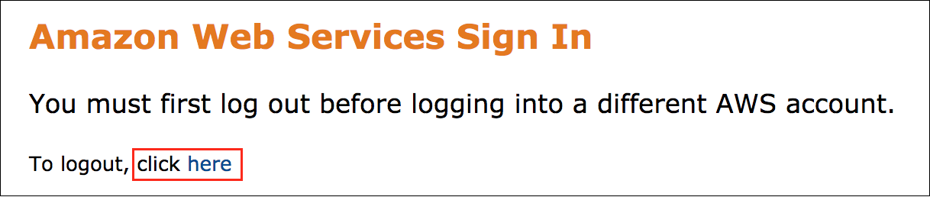

If you see the message, **You must first log out before logging into a different AWS account:**

* Choose the **click here** link.
* Close your **Amazon Web Services Sign In** web browser tab and return to your initial lab page.
* Choose **Open Console** again.

**Error: Choosing Start Lab has no effect**

In some cases, certain pop-up or script blocker web browser extensions might prevent the **Start Lab** button from working as intended. If you experience an issue starting the lab:

* Add the lab domain name to your pop-up or script blocker’s allow list or turn it off.
* Refresh the page and try again.

**Task 1: Ingest data into SPICE**

Before you analyze your client’s data, you need to upload and prepare the dataset.

QuickSight provides two modes of ingestion from data sources: direct query and caching data into SPICE. When you upload file-based data, QuickSight defaults to SPICE. If you connect to a database, you can choose between direct query and SPICE.

*SPICE* (Super-fast, Parallel, In-memory Calculation Engine) is the robust in-memory caching engine that Amazon QuickSight uses. It’s engineered to rapidly perform advanced calculations and serve data.

**Learn more:** Refer to [Importing data into SPICE](https://docs.aws.amazon.com/quicksight/latest/user/spice.html) for more information about SPICE.

In this task, you load in a dataset from an Excel file. After loading it into QuickSight, you explore the data and prepare it for analysis.

1. At the top of the AWS Management Console page, in the unified search bar, search for and choose

QuickSight

.

The QuickSight console opens.

1. Save the [all-cancelled-flights.csv](https://us-west-2-tcprod.s3.amazonaws.com/courses/SPL-TF-100-ANQSDB/v1.0.6.prod-e4dc4015/scripts/all-cancelled-flights.csv) file to your local machine.

**Note:** To save the file from your browser, right-click the link and choose “Save link as…”.

**Caution:** This dataset contains almost 250,000 records and might take 1-3 minutes to download, depending on your internet connection speed. Make sure the file is downloaded before continuing with the next steps.

1. In the navigation pane at the left of the page, choose **Datasets**.
2. Choose **New dataset**.
3. Choose **Upload a file** from the list of sources.
4. Select the **all-cancelled-flights.csv** file you saved to your local machine and choose **Open**.

**Note:** If you receive a SPICE error stating that *You have no SPICE capacity available*, please do the following:

* Choose the person  icon at the top-right of the screen.
* Choose **Manage QuickSight**.
* Choose **SPICE capacity**.
* Choose **Purchase more capacity**.
* Enter

1

.

* Choose **Purchase SPICE capacity**.
* After purchasing the SPICE capacity, reupload the **all-cancelled-flights.csv** file.

1. After the preview loads, choose **Next**.
2. Choose **Edit/Preview data**.

**Task complete:** You have successfully ingested data into SPICE.

**Task 2: Prepare data**

To effectively visualize the data, you start by preparing the dataset. This dataset has some column names that are incomplete, fields that can be removed, data types that are incorrect, custom fields that have not been added yet, and another dataset to join. In addition to the **all-cancelled-flights.csv** file, the client provided you with a table that includes the description of each of the cancellation codes.

In this task, you prepare your dataset by editing column names, excluding fields, changing data types, creating custom fields, and joining two tables together.

**Consider:** You are in the QuickSight dataset editor. Take a moment to explore the editor, organized into five key sections:

* The **menu bar**, located at the top of the QuickSight page
* The **navigation pane**, located at the left of the QuickSight page
* The **Fields pane**, located next to the navigation pane
* The **Data workspace**, located in the middle of the QuickSight page
* The **Dataset preview**, located at the bottom of the page

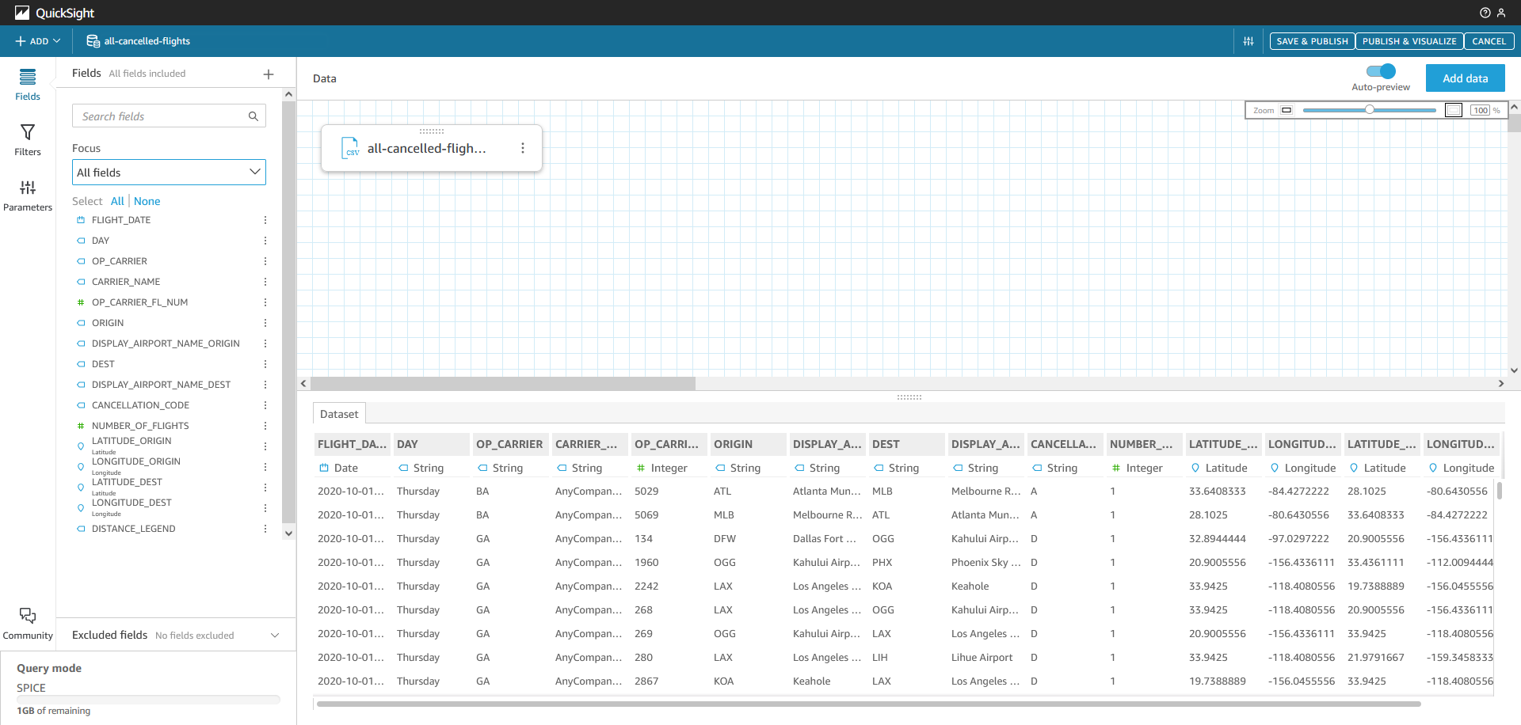

*Image description: The QuickSight dataset editor includes a menu bar, navigation pane, fields pane, data workspace, and a dataset preview. The fields from the dataset are shown in the fields pane. The all-cancelled-flights.csv file is shown in the data workspace. A preview of the data is shown in the dataset preview.*

TASK 2.1: EDIT COLUMN NAMES

The **DEST** field stands for *Destination*. Edit the field to be named **DESTINATION**.

1. In the **Fields** pane, choose the ellipsis icon next to **DEST**.
2. Choose **Edit name & description**.
3. For **Name**, clear the value and enter

DESTINATION

.

1. Choose **Apply**.

The **DEST** field is renamed to **DESTINATION**. You can see the change populate in the *Fields* pane and the *Dataset* preview.

TASK 2.2: CHANGE DATA TYPES

The **OP_CARRIER_FL_NUM** field is set as a *Measure* right now. Change it to be a *String* instead so it is automatically a *Dimension* instead of a *Measure*.

1. In the **Fields** pane, choose the ellipsis icon next to **OP_CARRIER_FL_NUM**.
2. Choose **Change data type**, and then select **String**.

The *Dataset* preview reloads. Notice the **OP_CARRIER_FL_NUM** data type is set to *String*.

TASK 2.3: ADD FIELDS TO COORDINATES

To simplify the airport locations, add **LATITUDE_ORIGIN** and **LONGITUDE_ORIGIN** to coordinates called **ORIGIN_GEO**. Then, add **LATITUDE_DEST** and **LONGITUDE_DEST** to coordinates called **DESTINATION_GEO**.

First, create a coordinate for **ORIGIN_GEO**.

1. In the **Fields** pane, choose the ellipsis icon next to **LATITUDE_ORIGIN**.
2. Choose **Add to coordinates**.
3. Select **Create new geospatial coordinates**.
4. Choose **Add**.
5. For **Name your coordinates**, enter

ORIGIN_GEO

.

1. For **Field to use for longitude**, select **LONGITUDE_ORIGIN**.
2. Choose **Create coordinates**.

Then, create a coordinate group for **DESTINATION_GEO**.

1. In the **Fields** pane, choose the ellipsis icon next to **LATITUDE_DEST**.
2. Choose **Add to coordinates**.
3. Select **Create new geospatial coordinates**.
4. Choose **Add**.
5. For **Name your coordinates**, enter

DESTINATION_GEO

.

1. For **Field to use for longitude**, select **LONGITUDE_DEST**.
2. Choose **Create coordinates**.

You have created two coordinates, one for *ORIGIN_GEO* and one for *DESTINATION_GEO*.

TASK 2.4: EXCLUDE FIELDS

The **DISTANCE_LEGEND** field includes data you do not need because distance can be calculated more granularly from the coordinates you just created. Remove this field from the dataset.

1. In the **Fields** pane, choose the ellipsis icon next to **DISTANCE_LEGEND**.
2. Choose **Exclude field**.

**Note:** Changes made during data preparation are not automatically saved. Periodically save and publish your work while you prepare you dataset.

1. In the top menu bar, choose **SAVE & PUBLISH**.

The field is excluded from the dataset and does not show up when you begin working on your visualization.

TASK 2.5: JOIN TABLES

The **CANCELLATION_CODE** field values are A, B, C, and D. These values do not hold meaning that you can clearly translate on a visualization. You can resolve this issue by joining the **cancellation-codes.csv** file that contains descriptions of the cancellation codes to the dataset you just edited.

1. Save the [cancellation-codes.csv](https://us-west-2-tcprod.s3.amazonaws.com/courses/SPL-TF-100-ANQSDB/v1.0.6.prod-e4dc4015/scripts/cancellation-codes.csv) file to your local machine.

**Note:** To save the file from your browser, right-click the link and choose “Save link as…”.

1. In the **Data** section, choose **Add data**.
2. For **Add data**, select **Upload a file**.
3. Select the **cancellation-codes.csv** file you saved to your local machine and choose **Open**.
4. After the preview loads, choose **Next**.

Join the tables together using a left join.

1. Choose the two dots between the data sources to configure the join.
2. Under **Join configuration**, in the **all-cancelled-flights.csv** section, select the **CANCELLATION_CODE** field from the dropdown list.
3. Under **Join configuration**, in the **cancellation-codes.csv** section, select the **Code** field from the dropdown list.

**Note:** For this join, you can leave the join type as **Left**.

**Learn more:** QuickSight provides many ways to join your data, and it automatically recommends the optimum join type for your datasets. Refer to [Joining data](https://docs.aws.amazon.com/quicksight/latest/user/joining-data.html) for more information about joining data in QuickSight.

1. To finalize the join, choose **Apply**.
2. In the top menu bar, choose **SAVE & PUBLISH**.

**Consider:** What are some ways that you can use QuickSight joins to pull together tables from many sources that are ready for analysis? Would any other data sources augment your sales dashboard?

The join added both columns from the new dataset. The **CANCELLATION_CODE** and **Code** fields contain the same information. To keep the data clean, remove the **CANCELLATION_CODE** field, rename **Code** to **CODE**, and rename **Description** to **CODE_DESCRIPTION**.

1. In the **Fields** pane, choose the ellipsis icon next to **CANCELLATION_CODE**.
2. Choose **Exclude field**.
3. In the **Fields** pane, choose the ellipsis icon next to **Code**.
4. Choose **Edit name & description**.
5. For **Name**, clear the value and enter

CODE

.

1. Choose **Apply**.
2. In the **Fields** pane, choose the ellipsis icon next to **Description**.
3. Choose **Edit name & description**.
4. For **Name**, clear the value and enter

CODE_DESCRIPTION

.

1. Choose **Apply**.

Your dataset is prepared and ready to visualize. You can publish the dataset now.

1. In the top menu bar, choose **SAVE & PUBLISH**.

**Task complete:** You have successfully prepared your data and are ready to visualize it in a dashboard.

**Task 3: Create visualizations**

The client asked you to create a dashboard that includes the following visualizations:

* A bar chart that shows the number of flights by airline.
* A geospatial chart that shows the reason for flight cancellations by destination.
* A Sankey diagram that shows the flow from origin airports to cancellation reason.
* A line chart that shows the number of flights per month with a forecast that estimates future flights per month.
* A filter that can filter all visualizations by origin.
* A new sheet for additional charts.
* A pie chart that shows the cancellation reason by airline carrier.
* A filter action that filters all other visualizations by selecting a component of another visualization.
* An ML insight that finds if there are any anomalies for cancellations in the dataset.

Work through each visualization and build out your dashboard.

In this task, you create a bar chart, a geospatial chart, a Sankey diagram, a filter, a new sheet, a pie chart, a filter action, and add an ML insight to the dashboard.

TASK 3.1: CREATE A BAR CHART

First, create a bar chart that shows the number of flights by airline. Use *NUMBER_OF_FLIGHTS* and *CARRIER_NAME* to create this bar chart.

1. Choose the upper left **QuickSight** icon.
2. In the navigation pane at the left of the page, choose **Analyses** if it is not already selected.
3. Choose **New analysis**.
4. For **Your Datasets**, choose **all-cancelled-flights**.
5. **USE IN ANALYSIS**.
6. Verify that **Interactive sheet** is selected and choose **Create**.

**Note:** You can read and close any pop-up menus before continuing.

**Consider:** You are now in the QuickSight dashboard editor. Take a moment to explore the editor, organized into six key sections:

* The **menu bar**, located at the top of the QuickSight page
* The **Analysis toolbar**, located below the menu bar.
* The **Data pane**, located at the left of the QuickSight page
* The **Visuals pane**, located next to the Data pane
* The **dashboard workspace**, located in the middle of the QuickSight page
* The **visualization menu**, located in the dashboard workspace on each visualization with pencil, maximize, and ellipsis icons (only visible if you have selected a visualization on the sheet)

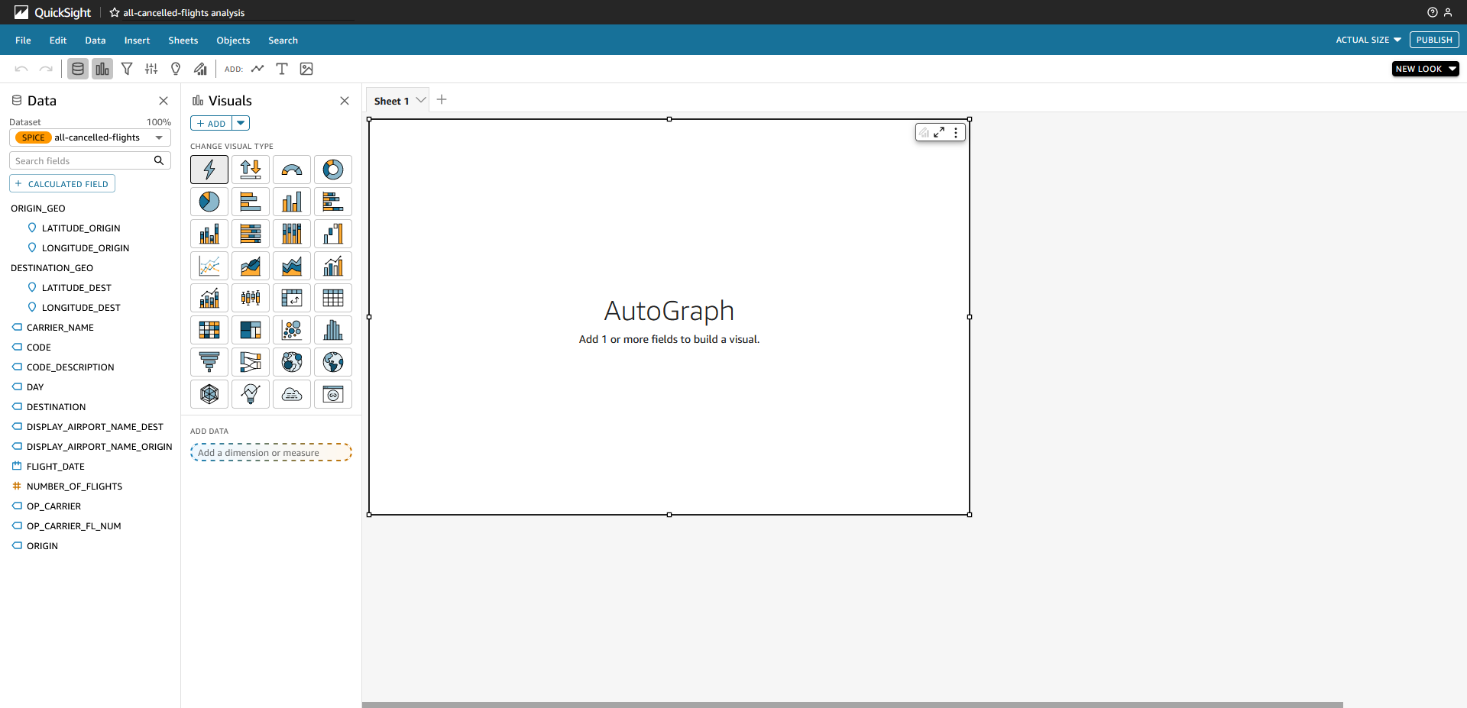

*Image description: The QuickSight dashboard editor includes a menu bar, Analysis toolbar, Data pane, Visuals pane, dashboard workspace, and a visualization menu. The fields from the dataset are shown in the Data pane. An AutoGraph is shown in the dashboard workspace. A group of visualization type icons is shown in the Visuals pane.*

1. In the dashboard workspace, choose the **AutoGraph** visualization.
2. In the **Data** pane, select **NUMBER_OF_FLIGHTS** and then select **CARRIER_NAME**.

**Note:** If the data does not appear right away, wait until the bar chart data populates.

A bar chart appears with the number of flights by airline ranging from almost 50,000 flights to less than 1,500 flights. AutoGraph in QuickSight intuitively selects visualizations that work with the data fields you select.

1. Adjust the vertical bar between the carrier names and the bars on the bar chart until you can see all of the carrier names.
2. On your bar chart visualization, to open the **Properties** pane, choose the pencil icon.
3. Choose **Display Settings**.
4. Choose the paintbrush icon next to **Edit title**.
5. For **Edit title**, enter

Cancelled Flights by Carrier

.

1. Choose **Save**.
2. To close the **Properties** pane, choose **x**.

Which airline has the most flights? Which airline has the least flights?

**Answer**

You created your first QuickSight visualization.

TASK 3.2: CREATE A GEOSPATIAL CHART

Next, create a geospatial chart that shows the reason for flight cancellations by destination.

1. To add a new visualization, in the **Visuals** pane, choose **+ ADD**.
2. In the **Visuals** pane, choose **Points on map**.

**Note:** Choose any of the icons in the **Visuals** pane to view the visual type name.

1. In the **Data** pane, select **DESTINATION_GEO**, **CODE** and **NUMBER_OF_FLIGHTS**.
2. Zoom into the map until the **UNITED STATES** is centered in the visualization and most of the points are showing.
3. On your map visualization, to open the **Properties** pane, choose the pencil icon.
4. Choose **Display Settings** if it is not already expanded.
5. Choose the paintbrush icon next to **Edit title**.
6. For **Edit title**, enter

Cancellation Reason by Destination Airport

.

1. Choose **Save**.
2. To close the **Properties** pane, choose **x**.

Which destination has the largest number of flights for one code type?

**Note:** You can zoom into the map to get a better view of what is located at any geospatial point.

**Answer**

Cancellation codes are useful if you already know what the codes mean, but for readers who are unfamiliar with the codes, it is helpful to provide a more meaningful description. To improve the readability of the visualization, replace the **CODE** field with the **CODE_DESCRIPTION** field.

1. In the **Visuals** pane, choose the ellipsis icon next to **CODE**.
2. Choose **Remove**.
3. In the **Data** pane, choose **CODE_DESCRIPTION**.

The visualization updates. The *B* code stands for *Weather*, so the DFW airport has the most cancellations due to weather.

TASK 3.3: CREATE A SANKEY DIAGRAM

Next, create a Sankey diagram that shows the flow from origin airports to cancellation reason.

1. To add a new visualization, in the **Visuals** pane, choose **+ ADD**.
2. In the **Visuals** pane, choose **Sankey diagram**.
3. In the **Data** pane, select **DISPLAY_AIRPORT_NAME_ORIGIN**, **CODE_DESCRIPTION** and **NUMBER_OF_FLIGHTS**.
4. Use the small boxes at the edge of the visualization to expand the visualization until you can see all of the origin airport names.
5. On your Sankey diagram visualization, to open the **Properties** pane, choose the pencil icon.
6. Choose **Display Settings** if it is not already expanded.
7. Choose the paintbrush icon next to **Edit title**.
8. For **Edit title**, enter

Origin Airport Cancellation Reasons

.

1. Choose **Save**.
2. To close the **Properties** pane, choose **x**.

The Sankey diagram shows the relationship between each airport and the cancellation reasons.

TASK 3.4: ADD AN ML-POWERED FORECAST TO A VISUALIZATION

Amazon QuickSight uses machine learning (ML) to help you uncover hidden insights and trends in your data, identify key drivers, and forecast business metrics. You can also consume these insights in natural language narratives embedded in dashboards. QuickSight has ML-powered insights that can quickly provide forecasts or identify anomalies in the dataset.

Create a line chart that shows the number of flights per month with an ML-powered forecast that estimates future flights per month.

1. To add a new visualization, in the **Visuals** pane, choose **+ ADD**.
2. In the **Visuals** pane, choose **Line chart**.
3. In the **Data** pane, select **FLIGHT_DATE** and **NUMBER_OF_FLIGHTS**.
4. In the **Visuals** pane, choose the ellipsis icon next to **FLIGHT_DATE**.
5. Choose **Aggregate: Day**.
6. Choose **Month**.

The line chart changes to show the data aggregated by month instead of day.

1. In the visualization menu on the right of your line chart visualization, select the ellipsis icon, and then select **Add forecast**.

An ML-powered forecast appears, predicting the next 14 months of flights. Because there can never be fewer than 0 flights, set the forecast minimum to 0.

1. In the **Forecast properties** pane, select **Forecast minimum**.
2. For **Forecast minimum**, enter

0

.

1. Choose **APPLY**.

**Learn more:** Refer to [Forecasting and creating what-if scenarios with Amazon QuickSight](https://docs.aws.amazon.com/quicksight/latest/user/forecasts-and-whatifs.html) for more information about creating forecasts in QuickSight.

1. On your line chart visualization, to open the **Properties** pane, choose the pencil icon.
2. Choose **Display Settings** if it is not already expanded.
3. Choose the paintbrush icon next to **Edit title**.
4. For **Edit title**, enter

Cancelled Flights per Month

.

1. Choose **Save**.
2. To close the **Properties** pane, choose **x**.

You created a visualization that shows the number of flights per month and includes an ML-powered forecast for the next 14 months of flights.

TASK 3.5: ADD A FILTER

You have four visualizations that show information about the airlines, the reasons for destination airport cancellations, and the relationship between the origin airports and the cancellation reasons. If you want to dig into a specific airport, it is helpful to have filters that you can adjust on the dashboard that interact with the visualizations.

To get started with filtering, create a filter for all visualizations by origin.

1. Choose the Sankey diagram.
2. In the Analysis pane below the menu bar, choose the **Filter** icon.
3. In the **Filters** pane, choose **+ ADD**.
4. Select **DISPLAY_AIRPORT_NAME_ORIGIN** from the list.
5. In the **Filters** pane, choose **DISPLAY_AIRPORT_NAME_ORIGIN** to expand the filter options.

**Note:** By default, QuickSight applies a new filter only on the visual selected when you created the filter. If you want a filter to apply to all visuals, adjust the filter settings to **All applicable visuals**.

1. In the **Edit filter** section, choose **Only this visual**, and then select **All applicable visuals** to filter all of the visualizations on your dashboard at the same time.
2. Choose the ellipsis icon next to the **DISPLAY_AIRPORT_NAME_ORIGIN** filter, and then select **Add to sheet**.
3. Move the filter to the top of the dashboard workspace.

Which airline had the most flights from Washington Dulles International (IAD)? What was the most common reason for flight cancellations from IAD?

**Note:** You can search for values when you select a filter. Try searching for

Washington Dulles International

.

1. Choose **Select all** to clear the selection.
2. Choose **Washington Dulles International** to select all of the flights that originated from IAD.

**Answer**

CHALLENGE A: ADD MORE FILTERS

Add two more filters to the dashboard: one that filters by the *FLIGHT_DATE* and one that filters by *CARRIER_NAME*.

**Hint 1**

**Hint 2**

**Hint 3**

**Solution**

TASK 3.6: ADD A SECOND SHEET

A sheet is a set of visuals that are viewed together in a single page. When you create an analysis, you place visuals in the workspace on a sheet. You can add more sheets, and make them work separately or together in your analysis.

Create a new sheet and rename it.

1. In the dashboard workspace, above the main visuals, choose (double-click) the **Sheet 1** tab, and then enter

Summary

 to rename it.

1. Choose the **+** next to the **Summary** tab to create a new sheet.
2. Verify that **Interactive sheet** is selected, then choose **Add**.
3. Choose (double-click) the **Sheet 2** tab, and then enter

Cancellation by Airline

 to rename it.

You created a second sheet.

TASK 3.7: CREATE A PIE CHART

On the *Cancellation by Airline* sheet, create a set of pie charts that show the cancellation reasons for each airport.

1. Choose the **AutoGraph** visualization.
2. In the **Visuals** pane, choose **Pie chart**.
3. In the **Data** pane, select **CODE_DESCRIPTION**, **NUMBER_OF_FLIGHTS** and **CARRIER_NAME**.

A group of pie charts appear. There is one pie chart for each airline.

1. On your pie chart visualization, to open the **Properties** pane, choose the pencil icon.
2. Choose **Display Settings** if it is not already expanded.
3. Choose the paintbrush icon next to **Edit title**.
4. For **Edit title**, enter

Carrier Cancellation Reasons

.

1. Choose **Save**.
2. To close the **Properties** pane, choose **x**.

Which airline has never cancelled a flight for *National Air System* and *Security*? How many fights has this airline cancelled?

**Answer**

TASK 3.8: ADD A FILTER ACTION

The client wants to select items on the dashboard and have other visualizations on the sheet automatically filter based on their selection.

To add interactive options in QuickSight, you create custom actions on one or more visuals in your analysis. A QuickSight filter action filters data included in a visual or the entire sheet.

Create a filter action on the *Summary* sheet. Then, test out the filter action by selecting airlines from the bar chart to see the map and Sankey diagram automatically filter based on the airline selection.

1. Choose the **Summary** tab.

What happens when you select an airline from the bar chart?

**Answer**

1. On your bar chart visualization, to open the **Properties** pane, choose the pencil icon.
2. In the **Properties** pane, choose **Interactions**.
3. Choose **Actions**.
4. Choose **ADD ACTION**.
5. For **Action name**, enter

Filter same-sheet visuals

.

1. Choose **Save**.
2. To close the **Properties** pane, choose **x**.

What happens when you select an airline from the bar chart with the filter action added on the sheet?

**Answer**

You added a filter action to the dashboard that increases the visualization interactivity.

TASK 3.9: ADD AN ML INSIGHT TO THE DASHBOARD

The client wants to know if there are any anomalies for weather cancellations in the dataset. Use an ML insight to find if there are any anomalies.

1. In the Analysis pane below the menu bar, choose the **Insights** icon.
2. For **Suggested insights**, choose **+ ADD**.
3. For **Computation type**, select **Anomaly detection (ML-powered insight)**.
4. Choose **Select**.
5. In the **Data** pane, select **FLIGHT_DATE**, **CODE_DESCRIPTION** and **NUMBER_OF_FLIGHTS**.
6. In the insight, choose **Get started**.
7. Choose **Save**.
8. On your insight, to open the **Properties** pane, choose the pencil icon.
9. Choose **Visual** if it is not already selected.
10. Choose **Display Settings** if it is not already expanded.
11. Choose the paintbrush icon next to **Edit title**.
12. For **Edit title**, clear the current title, and then enter

Cancellation Anomalies

.

1. Choose **Save**.
2. To close the **Properties** pane, choose **x**.
3. Choose **Run now**.
4. Wait until the ML-powered insight has finished analyzing the data.

**Caution:** The insight can take 2-3 minutes to report on any anomalies in the dataset. Wait until the insight has finished so you can view the results. Once the insight has finished, you can move on to the next task.

You added an ML insight to the dashboard and viewed the detected anomaly.

CHALLENGE B: ORGANIZE YOUR DASHBOARD

Before you deliver the dashboard to your client, organize the visualizations, filters, and insight on your dashboard. Take some time to move the visuals around until you are satisfied with the final layout. Consider how you want to present the sales story to your client.

**Hint**

**Solution**

**Task complete:** You have successfully created visualizations, a sheet, filters, a filter action, and an ML-powered insight. You investigated the data as you built your dashboard and found information that is valuable to your client. Your dashboard is complete and is ready to publish.

**Task 4: Publish a dashboard**

Publish the dashboard so your client can view the dashboard you created.

1. In the top menu bar, choose **PUBLISH**.
2. For **Publish new dashboard as**, enter

Cancelled Flights

.

1. Choose **Publish dashboard**.

You are automatically redirected to your dashboard. Take a moment to explore the work you just completed.

**Learn more:** A dashboard is a read-only snapshot of an analysis that you can share with other Amazon QuickSight users for reporting purposes. Refer to [Sharing and subscribing to data in Amazon QuickSight](https://docs.aws.amazon.com/quicksight/latest/user/working-with-dashboards.html) for more information about dashboard sharing capabilities, including automated dashboard reporting.

**Task complete:** You have successfully published your dashboard.

**Challenge tasks (optional)**

After you shared the dashboard with the client, they sent over a few more requests. They want to be able to drill down into the pie charts on the *Cancellation by Airline* sheet, view all of the data in a table, and see some additional insights. Walk through each of these challenge tasks to update the dashboard.

CHALLENGE C: DRILL DOWN INTO A PIE CHART (OPTIONAL)

First, add a drill-down layer for **DISPLAY_AIRPORT_NAME_ORIGIN** on the *Cancellation by Airline* pie chart.

**Hint**

**Solution**

CHALLENGE D: CREATE A TABLE VISUALIZATION (OPTIONAL)

Next, create a table visualization showing the details from the dataset. The client wants to be able to reference the dataset for ad hoc analysis.

**Hint**

**Solution**

CHALLENGE E: ADD A NEW INSIGHT TO THE DASHBOARD (OPTIONAL)

The client wants to see the top three cancellation reasons on the *Summary* sheet.

**Hint**

**Solution**

CHALLENGE F: UPDATE A DASHBOARD (OPTIONAL)

You have completed the updates the client requested. Publish the new dashboard.

**Hint**

**Solution**

**Task complete:** You have successfully completed the client’s requests, drilling down into the pie chart, creating a table visualization, adding a new insight, and updating the dashboard.

**Conclusion**

You have successfully done the following:

* Ingested and prepared data by using Amazon QuickSight
* Created an analysis and dashboard
* Created visualizations and insights
* Published a QuickSight dashboard

**End lab**

Follow these steps to close out the console and end your lab.

1. At the upper-right corner of the QuickSight console, choose the user icon and then choose **Sign out**.
2. On this screen, choose **End lab** and then confirm that you want to end your lab.

For more information about AWS Training and Certification, see [*https://aws.amazon.com/training/*](https://aws.amazon.com/training/).

*Your feedback is welcome and appreciated.*  
If you would like to share any feedback, suggestions, or corrections, please provide the details in our [*AWS Training and Certification Contact Form*](https://support.aws.amazon.com/#/contacts/aws-training).